**Research Project Report**

**Title: Efficient Heart Sound Classification using Contrastive Learning based Knowledge Distillation**

Name: Barish Sarkhel

IVR No: 20201242

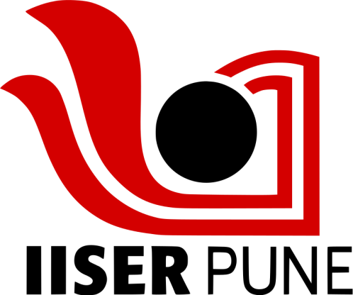 

**Project Completion Certificate:**

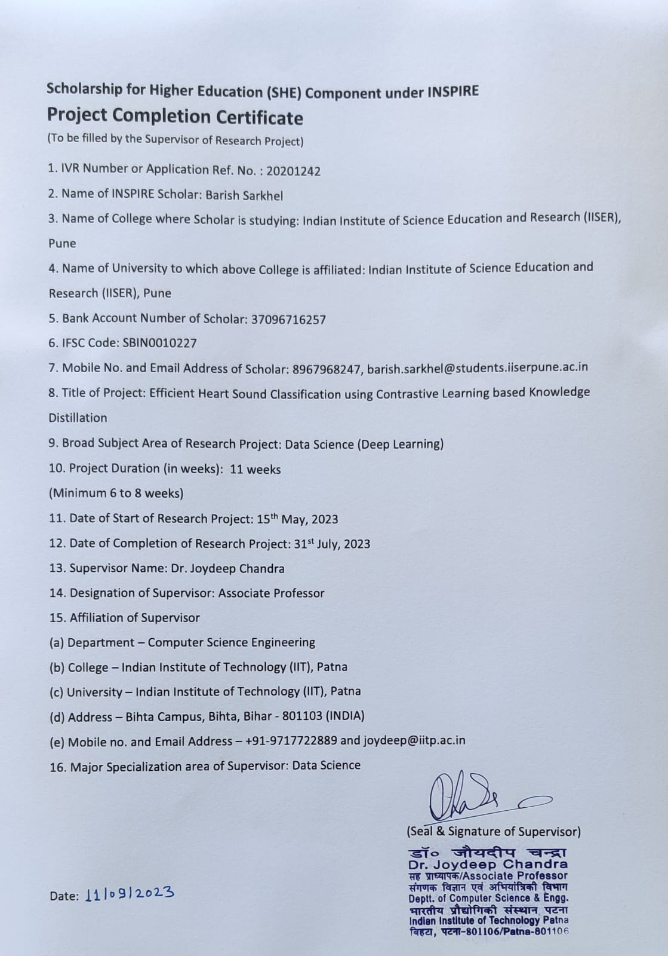

**Acknowledgement:**

I would like to express my heartfelt gratitude to the Indian Institute of Technology Patna (IIT), for providing me with the opportunity to undertake a summer project during the months of May to July. This valuable experience has been an enriching and enlightening journey for me.

I extend my sincere thanks to Professor Dr. Joydeep Chandra for his unwavering support, guidance, and mentorship throughout this project. His expertise, insights, and dedication to the field of Data science especially in Knowledge Distillation and Audio classification using different deep learning methods have been instrumental in shaping my understanding and skills.

I am also deeply indebted to Mr. Sourav Sharma, a dedicated PhD student working under the supervision of Professor Dr. Joydeep Chandra. Sourav's expertise, patience, and willingness to share his knowledge and experience were invaluable in helping me navigate the intricacies of our research.

Furthermore, I would like to acknowledge my home institution, the Indian Institute of Science Education and Research (IISER) Pune, for encouraging and supporting my academic endeavours.

Last but not least, I want to express my gratitude to all the faculty members, researchers, and fellow students who provided assistance and valuable insights during the course of this project.

This project would not have been possible without the collective support and collaboration of these individuals and institutions. I am truly thankful to them.

**Title of Research Project:**

Efficient Heart Sound Classification using Contrastive Learning based Knowledge Distillation.

**Aim:**

The primary objective of this project was to delve into the application of contrastive learning-based knowledge distillation techniques to enhance the efficiency and accuracy of heart sound classification. Leveraging various deep learning methods, the aim was to develop a robust and high-performing model capable of accurately classifying heart sounds, with a particular focus on achieving efficiency gains with knowledge distillation.

**Introduction of Research Topic:**

Heart sound classification is a critical area in the field of medical diagnostics, with applications ranging from the early detection of cardiovascular diseases to the monitoring of patients' cardiac health. In recent years, deep learning techniques have demonstrated remarkable success in automating the process of heart sound analysis. However, the efficient utilization of these deep learning models remains a challenge, especially in resource-constrained environments such as real-time medical diagnosis.

This research project focuses on the enhancement of heart sound classification by incorporating contrastive learning-based knowledge distillation techniques. Knowledge distillation is a well-established method for model compression and transfer learning, wherein a compact model, known as the student, is trained to mimic the behaviour of a larger, more complex model, known as the teacher. By transferring the knowledge from the teacher model to the student, it is possible to reduce model complexity and computational requirements without compromising performance.

The specific objective of this study is to investigate how knowledge distillation, with a focus on contrastive learning, can improve the efficiency of heart sound classification using deep learning methods. We aim to develop a high-performing, resource-efficient model capable of accurate heart sound classification, which holds great promise for real-time medical applications where computational resources are limited.

In the following sections, we will discuss the background and related work in heart sound classification, outline the methodology employed in our research, present experimental results, and draw conclusions based on our findings.

**Theoretical Framework of Topic:**

Heart sound classification is a difficult task in the field of medical diagnosis and it can indicate different type of diseases not only heart related diseases. This classification is essential for the early detection of cardiovascular diseases and the continuous monitoring of patients' cardiac health. Traditional heart sound measurement which is done manually many times does not as effective as machine can do if we train properly.

Deep learning, a subset of machine learning, has revolutionized various fields, including medical image and audio analysis. By using Convolution neural networks we can make effective models which can predict heart sound in a better way.

Despite the success of deep learning models, may time these models use many features which make the model so large that it become difficult to run it in small devises where knowledge distillation plays a better role. Knowledge distillation is a technique that addresses the challenge of model efficiency without compromising performance. In knowledge distillation, a large, complex model, often referred to as the "teacher," transfers its knowledge to a smaller, more efficient model, known as the "student." This transfer of knowledge involves training the student model to mimic the behavior and predictions of the teacher model. Contrastive learning is a variant of knowledge distillation that focuses on enhancing the student's understanding by emphasizing the relative similarity or dissimilarity between data points. In the context of audio classification, contrastive learning aims to improve the student model's ability to distinguish between different heart sound classes by considering the relationships between audio samples.

The goal of this research project is to leverage contrastive learning-based knowledge distillation techniques to achieve efficient heart sound classification. By transferring knowledge from a teacher model to a student model through distillation layers using contrastive learning, the project aims to develop a more resource-efficient model capable of accurately classifying heart sounds. This approach has the potential to reduce the computational requirements, memory footprint, and inference time of the model, making it suitable for deployment in real-time medical diagnosis and remote monitoring applications.

Research Objectives--

1. Investigate the application of contrastive learning-based knowledge distillation techniques in the context of heart sound classification.

2. Design and implement an efficient student model through distillation layers capable of accurate heart sound classification.

3. Evaluate the performance of the student model in terms of classification accuracy, computational efficiency, and resource utilization.

4. Compare the efficiency and performance of the student model with traditional deep learning approaches.

**Profile of Organization and Research Lab:**

The Indian Institute of Technology Patna (IIT Patna) is a prestigious engineering institution in India known for its excellence in education, research, and innovation. IIT Patna has consistently ranked among the top engineering institutes in the country and is recognized for its world-class faculty, state-of-the-art infrastructure, and a commitment to fostering cutting-edge research. IIT Patna boasts a diverse and dynamic research environment with a wide range of research disciplines across engineering, technology, and sciences. The institute is dedicated to advancing knowledge and finding innovative solutions to global challenges. Research areas include [mention a few prominent research areas or departments relevant to your project.

IIT Patna is home to a distinguished faculty comprising accomplished researchers and educators who have made significant contributions to their respective fields. The institute also hosts a vibrant community of doctoral and postdoctoral researchers who actively engage in groundbreaking research projects. The research infrastructure at IIT Patna is world-class, featuring advanced laboratories, computational resources that support various research activities. This exceptional infrastructure enables researchers to conduct cutting-edge experiments and simulations. IIT Patna is actively involved in pioneering research projects that address critical challenges across diverse domains. The institute encourages student involvement in research through various programs and initiatives, providing students with valuable opportunities to contribute to cutting-edge research.

**Methodology Followed:**

As said earlier in this project we have tried to develop a robust and accurate Knowledge distillation model. To do the same we take data from two recourses. The recourses are- <http://www.peterjbentley.com/heartchallenge/> and <https://www.kaggle.com/code/brsdincer/heartbeat-sounds-classification-analysis/notebook> . Then we develop deep learning models and made some classical machine learning models. We used Conv1D, Conv2D, LSTM, RNN etc deep learning models.

After doing this first step we made distillation model i.e. student model and used the previous model as teacher model and distillate the knowledge from the teacher model to the student model.

After these steps to increase the accuracy of the model we used some accuracy increasing technique. Mainly K-mean clustering used on the teacher and student model which give some improvement in the model prediction. Also to analyse the model we used many plotting technique like model plotting, confusing matics,shap model etc.

**Analysis and Interpretation of Research Project:**

The datasets provided valuable audio recordings of heart sounds, which served as the foundation for our research. We embarked on the model development phase, which involved the creation of deep learning and classical machine learning models. Our deep learning models encompassed Conv1D, Conv2D, LSTM, and RNN architectures etc. These models were designed to extract intricate patterns and representations from the heart sound data, enabling accurate classification. To enhance the efficiency of our models, we implemented knowledge distillation. In this process, we introduced a "student" model and utilized the previously trained deep learning models as "teacher" models. The knowledge from the teacher models was distilled into the student model, facilitating the transfer of learned information. This knowledge transfer aimed to reduce the computational complexity and resource requirements of the student model while preserving or even improving its classification accuracy. We applied K-means clustering to both the teacher and student models to increase accuracy. We employed various visualization and analysis techniques, such as model plotting, confusion matrices, and SHAP (SHapley Additive exPlanations) models, to gain insights into the model's performance and behaviour.

Through thorough analysis and visualization techniques, we gained valuable insights into the model's performance and were able to identify areas of strength and potential improvement. These findings contribute to the advancement of efficient and accurate heart sound classification methods, with potential applications in real-time medical diagnosis and remote healthcare monitoring.

In summary, our research project successfully explored the integration of knowledge distillation and accuracy enhancement techniques in the context of heart sound classification, ultimately yielding a more efficient and accurate model. These findings have the potential to make a significant impact in the field of medical diagnostics and healthcare technology.

**Conclusion & Suggestion of Research Project:**

This was project based on a very popular field in data science more specifically in the field of deep learning and to implement these techniques in the heart sound data. Through the project we have learned about knowledge distillation which is basically used to reduce the size of the model to use it small devices. Through the process of the research I have understood different prospective of the method and how a complete model can be build with increasing accuracy from the existing resources.

The increase in accuracy and in the process of developing the model we have realised that many more techniques can be used to make the model smaller robust and more accurate. Also playing more with all the hyper parameters can give rise to some beautiful conclusion.

**Result(s) Achieved:**

The main aim of this project was to develop a knowledge distillation model on heart sound data and bring it to some optimal accuracy. As we discussed in the process we made several model and calculated their accuracy for both student and teacher. Also we made a scratch student model to track the development of the models. In an average in all model we achieved more than 80% accuracy. Also when we applied K-mean clustering we got 2 to 4 % increase in almost all the models.

**References:**

1. <https://iopscience.iop.org/article/10.1088/1361-6579/aa724c/meta>
2. <https://www.sciencedirect.com/science/article/pii/S266682702200038>X
3. <https://www.sciencedirect.com/science/article/pii/S2666827021001031>
4. https://www.kaggle.com/code/brsdincer/heartbeat-sounds-classification-analysis/notebook
5. <https://www.sciencedirect.com/science/article/pii/S1746809422006449>
6. <https://www.kaggle.com/datasets/kinguistics/heartbeat-sounds>
7. <https://towardsdatascience.com/explainable-ai-xai-with-shap-multi-class-classification-problem-64dd30f97cea>
8. <https://github.com/enkiwang/Portable-Skin-Lesion-Diagnosis>
9. <https://arxiv.org/ftp/arxiv/papers/2305/2305.00141.pdf>
10. <https://www.sciencedirect.com/science/article/pii/S1746809423003658>
11. <https://github.com/sovit-123/Robust_Neural_Networks_by_Adding_Noise_to_Data>
12. <https://github.com/sthalles/SimCLR>

Declaration by the Scholar: I am Barish Sarkhel hereby declare that the details/facts mentioned above are true to the best of my knowledge and I solely be held responsible in case of any discrepancies found in the details mentioned above.

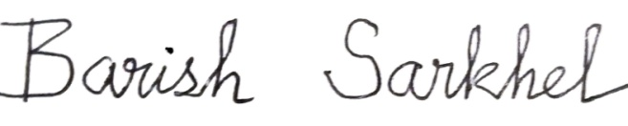

(Signature of Scholar)

Date: 12-09-2023

Place: IISER Pune, Pashan, Pune